Quick Start Guide for Fluke 43B Power Quality Analyzers 3Φ Live Reading

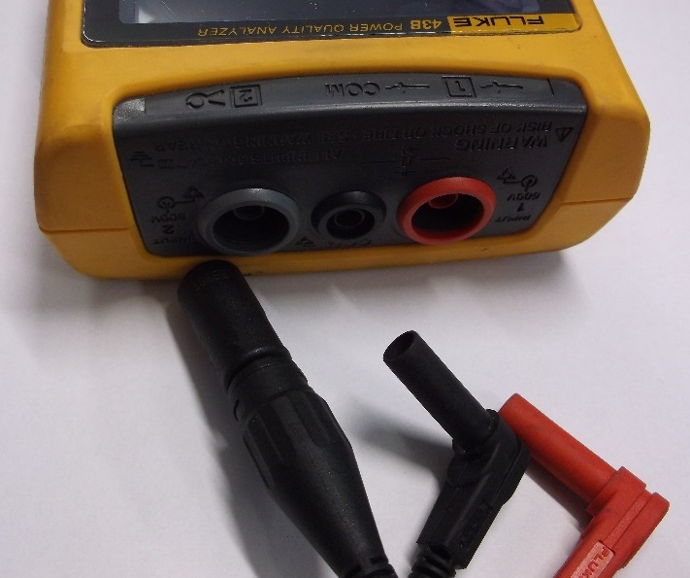 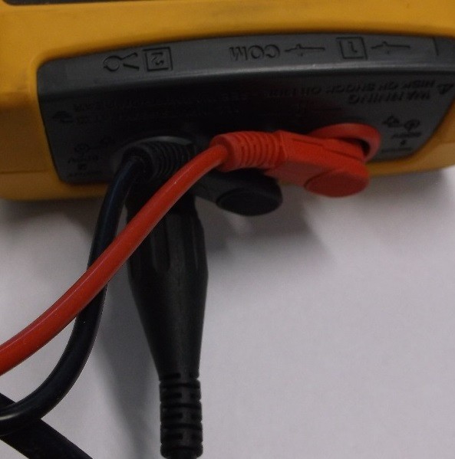 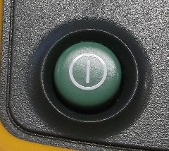 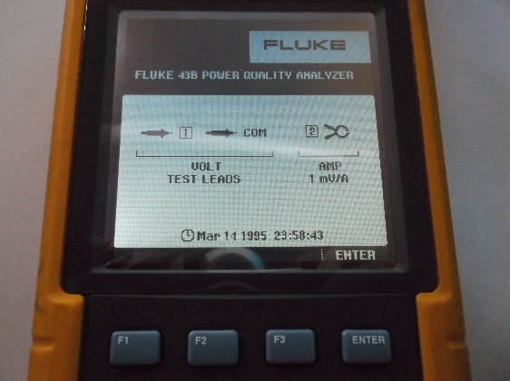 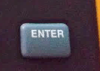 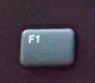 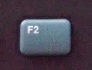

Show this screen to the electrician and hand them the clamp and probes. They will connect clamp around one hot leg, probe the other two. Does not matter which are selected. Stand back (ideally behind the cabinet door) and give the electrician as much space as possible.

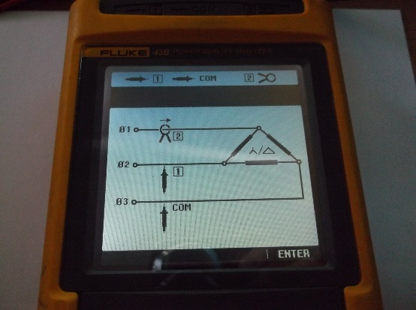  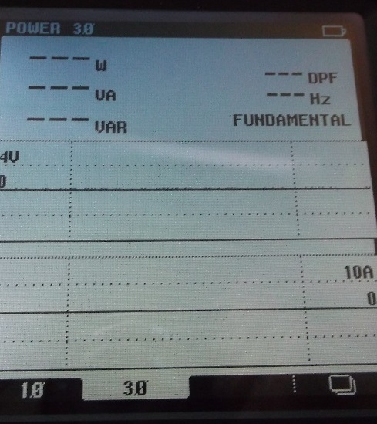

Write down the values circled in your notes or on data collection sheets.

 